Working Note
Tuesday, 31 January 2023
Metro Melbourne COVID019 2023 (second) survey
Residence one year before census analysis

Dr James Reynolds

Introduction
PTRG is undertaking a second survey of the impacts of COVID-19 on travel behaviour in Melbourne. One of the issues that may be relevant to this is residential relocation, being the possibility that people will move house (in part) because of changes to their work, life and/or travel patterns related to COVID-19.
PTRG has already undertaken a literature review of research about COVID-19 related residential relocation, and a review of the Australian Bureau of Statistics (ABS) data on internal migration. This is dated August 23, 2022 (COVID-19 residential relocation, Literature and data review) and located here. The literature review suggested two viewpoints on the impact of COVID-19 on city residential patterns, either: 1) there will be a large shift to low-density living and remote work; or 2) cities will continue to go on mostly as they have before, without a significantly large change to residential patterns. Unfortunately, it remains too early to for the research literature to be able to do much more than make predictions or provide insights based on stated preferences, and so there is little certainty about what will happen in the future.
PTRG was, however, able to use quarterly ABS data on internal migration, which is based on Medicare address records. Analysis of this dataset suggested that there has been a significant shift in population away from Melbourne since the beginning of COVID-19, with significant increases in net migration to the rest of Victoria (+1,250-1,500 additional people per quarter), non-Sydney parts of NSW (+2,000 additional people per quarter) and non-Brisbane parts of QLD (+2,500 additional people per quarter). However, these represent only a small fraction of Melbourne total population (~5 million) and net migration is complicated by a range of factors including: the ‘normal churn’ of people moving in and out of Melbourne (around 40-60,000 people moving in or out each quarter); very large reductions in the number of international arrivals to Australia; and delayed movement associated with Melbourne’s long period of lockdowns. The ABS data suggests that there has been a net reduction of in Melbourne’s population of around 8,000 more people per quarter in the year ending June 2021, compared to pre-COVID net migration. Data about the destination of people moving from Melbourne suggests that there has been 5-6,000 more people moving to non-Melbourne parts of Victoria in the first year of COVID-19 than in the year before-COVID-19.
During an internal PTRG meeting on the COVID-19 survey Liton Kamruzzam suggested looking also at the 2016 and 2021 Census data to explore changes to residential relocation related to COVID-19. The census includes questions about each person’s place of residence one year prior (i.e. 2015 and 2020) and five years prior (i.e. 2011 and 2016) to each census. This working note details finding of this analysis, focusing on the one-year-prior data so as to compare pre-COVID-19 (moves during 2015-16) and with-COVID-19 (moves during 2020-21).
The rest of the working note is structured as follows: the next section briefly describes the analysis methods and the overall results to the ‘residential location one year before the census’ questions during the 2016 and 2021 censuses. Section 3 then compares the rates of residential relocation away from the inner, middle and outer regions of Melbourne during the pre- and with-COVID-19 periods.

Methods and raw results
Data was obtained from the ABS Table Builder system for the Place of Usual Residence one year ago (PUR1P), and five years ago (PUR5P) questions for the 2016 and 2021 censuses. More details of the datasets obtained from the ABS website and the analysis undertaken can be found here.
Table 1 and Table 2 show results for the 2016 and 2021 censuses from the usual address one year ago question (PUR1P). The results by Local Government Area (LGA) were used, with aggregation to the regions (inner, middle, outer, peri-urban areas, rest of Victoria) as defined in the in the work to date

Table 1: Usual address one year before the 2016 census, by Melbourne and Victorian region
Region | Same as in 2016 | Inner | Middle | Outer | Peri-Urban Area | Rest of Victoria | NSW | QLD | SA | WA | TAS | NT | ACT | Other | Over-seas | Total
Inner | 264,649 (70.7%) | 367 (0.1%) | 4,379 (1.2%) | 23,344 (6.2%) | 6,463 (1.7%) | 35,915 (9.6%) | 3,933 (1.1%) | 2,932 (0.8%) | 1,054 (0.3%) | 1,957 (0.5%) | 534 (0.1%) | 300 (0.1%) | 705 (0.2%) | 14 (0.0%) | 27,844 (7.4%) | 374,390 (100.0%)
Middle | 1,605,376 (84.6%) | 1,206 (0.1%) | 33,254 (1.8%) | 15,336 (0.8%) | 53,571 (2.8%) | 114,989 (6.1%) | 6,911 (0.4%) | 5,189 (0.3%) | 2,598 (0.1%) | 3,154 (0.2%) | 1,008 (0.1%) | 719 (0.0%) | 1,155 (0.1%) | 18 (0.0%) | 53,493 (2.8%) | 1,897,977 (100.0%)
Outer | 1,496,836 (87.5%) | 10,166 (0.6%) | 55,710 (3.3%) | 3,649 (0.2%) | 19,768 (1.2%) | 84,288 (4.9%) | 5,716 (0.3%) | 4,262 (0.2%) | 1,782 (0.1%) | 2,144 (0.1%) | 698 (0.0%) | 641 (0.0%) | 531 (0.0%) | 12 (0.0%) | 24,902 (1.5%) | 1,711,105 (100.0%)
Peri-Urban Areas | 636,792 (85.8%) | 1,634 (0.2%) | 30,981 (4.2%) | 4,701 (0.6%) | 24,082 (3.2%) | 31,161 (4.2%) | 2,429 (0.3%) | 2,473 (0.3%) | 932 (0.1%) | 1,069 (0.1%) | 438 (0.1%) | 620 (0.1%) | 256 (0.0%) | 3 (0.0%) | 4,937 (0.7%) | 742,508 (100.0%)
Rest of Victoria | 522,054 (86.6%) | 765 (0.1%) | 9,732 (1.6%) | 17,879 (3.0%) | 16,543 (2.7%) | 22,255 (3.7%) | 4,624 (0.8%) | 2,344 (0.4%) | 1,188 (0.2%) | 1,057 (0.2%) | 334 (0.1%) | 556 (0.1%) | 246 (0.0%) | 6 (0.0%) | 3,507 (0.6%) | 603,090 (100.0%)
Total | 4,525,707 (84.9%) | 14,138 (0.3%) | 134,056 (2.5%) | 64,909 (1.2%) | 120,427 (2.3%) | 288,608 (5.4%) | 23,613 (0.4%) | 17,200 (0.3%) | 7,554 (0.1%) | 9,381 (0.2%) | 3,012 (0.1%) | 2,836 (0.1%) | 2,893 (0.1%) | 53 (0.0%) | 114,683 (2.2%) | 5,329,070 (100.0%)
Note: 1. People who had moved, but stayed within the same region are shown in the relevant column (e.g. 367 living in the inner region in 2016 had lived at a different address in the inner region in 2015) Source: Author analysis of ABS data
Table 2: Usual address one year before the 2021 census, by Melbourne and Victorian region
Region | Same as in 2016 | Inner | Middle | Outer | Peri-Urban Area | Rest of Victoria | NSW | QLD | SA | WA | TAS | NT | ACT | Other | Over-seas | Total
Inner | 287,174 (69.2%) | 544 (0.1%) | 7,347 (1.8%) | 37,043 (8.9%) | 11,008 (2.7%) | 52,169 (12.6%) | 4,408 (1.1%) | 2,892 (0.7%) | 1,113 (0.3%) | 1,383 (0.3%) | 677 (0.2%) | 333 (0.1%) | 745 (0.2%) | 4 (0.0%) | 8,276 (2.0%) | 415,116 (100.0%)
Middle | 1,748,083 (86.0%) | 1,638 (0.1%) | 37,938 (1.9%) | 16,831 (0.8%) | 64,919 (3.2%) | 131,633 (6.5%) | 5,402 (0.3%) | 3,507 (0.2%) | 1,450 (0.1%) | 1,292 (0.1%) | 1,089 (0.1%) | 578 (0.0%) | 842 (0.0%) | 0 (0.0%) | 18,159 (0.9%) | 2,033,361 (100.0%)
Outer | 1,819,216 (88.7%) | 10,226 (0.5%) | 63,157 (3.1%) | 5,315 (0.3%) | 22,749 (1.1%) | 106,350 (5.2%) | 4,426 (0.2%) | 2,886 (0.1%) | 1,210 (0.1%) | 1,016 (0.0%) | 782 (0.0%) | 566 (0.0%) | 418 (0.0%) | 3 (0.0%) | 12,384 (0.6%) | 2,050,704 (100.0%)
Peri-Urban Areas | 751,873 (86.2%) | 1,842 (0.2%) | 38,090 (4.4%) | 5,441 (0.6%) | 27,380 (3.1%) | 38,089 (4.4%) | 2,260 (0.3%) | 1,851 (0.2%) | 711 (0.1%) | 682 (0.1%) | 531 (0.1%) | 367 (0.0%) | 261 (0.0%) | 0 (0.0%) | 3,061 (0.4%) | 872,439 (100.0%)
Rest of Victoria | 566,460 (87.3%) | 922 (0.1%) | 10,500 (1.6%) | 17,770 (2.7%) | 17,331 (2.7%) | 24,419 (3.8%) | 4,759 (0.7%) | 2,022 (0.3%) | 903 (0.1%) | 501 (0.1%) | 342 (0.1%) | 437 (0.1%) | 304 (0.0%) | 0 (0.0%) | 2,139 (0.3%) | 648,809 (100.0%)
Total | 5,172,806 (85.9%) | 15,172 (0.3%) | 157,032 (2.6%) | 82,400 (1.4%) | 143,387 (2.4%) | 352,660 (5.9%) | 21,255 (0.4%) | 13,158 (0.2%) | 5,387 (0.1%) | 4,874 (0.1%) | 3,421 (0.1%) | 2,281 (0.0%) | 2,570 (0.0%) | 7 (0.0%) | 44,019 (0.7%) | 6,020,429 (100.0%)
Source: Author analysis of ABS data
An example comparison between Table 1 and Table 2 is:
- In 2016, 264,649 people (70.7% of the total 374,390) living in inner Melbourne on the day of the census were living at the same address as they were one year earlier (in 2015). In comparison,
- in 2021 287,174 people (69.2% of the total 415,116) living in inner Melbourne were living at the same address as they were one year earlier (in 2020).
- This suggests that more people, but a lower proportion of the inner population, were living at the same address as they had been one year earlier after the beginning of COVID-19 (2020-21) compared to pre-COVID (2015-16).
More broadly, there is a lot of information included in Table 1 and Table 2. Hence, the next section focuses directly on our area of interest; residential relocation away from (the different parts) of Melbourne.

Movement FROM regions of Greater Melbourne
Table 3 shows the place of usual residence at the time of each census, with people grouped by which region of Melbourne they were living in one year prior to the census. This is based on a rearrangement of the data in Table 1 and Table 2, plus the addition of further data about where those who moved from Melbourne to the rest of Australia moved to. Note that it is not possible to include people who moved from Melbourne to locations overseas in this table, as those living overseas at the time of the census are not included in the census. Full details of the supporting analysis are provided in section 4.1 of the working notes.
Table 3: Residential location at the time of the census of those living in Greater Melbourne one year prior to each census, by region
Destination | Inner |  | Middle |  | Outer |  | All Melbourne
Destination | 2015-16 | 2020-21 | 2015-16 | 2020-21 | 2015-16 | 2020-21 | 2015-16 | 2020-21
Did not move | 264,649 (93.4%) | 287,174 (92.7%) | 1,605,376 (91.5%) | 1,748,083 (90.5%) | 1,496,836 (95.1%) | 1,819,216 (94.6%) | 3,366,861 (93.2%) | 3,854,473 (92.6%)
Inner | 367 (0.1%) | 544 (0.2%) | 4,379 (0.2%) | 7,347 (0.4%) | 23,344 (1.5%) | 37,043 (1.9%) | 28,090 (0.8%) | 44,934 (1.1%)
Middle | 1,206 (0.4%) | 1,638 (0.5%) | 33,254 (1.9%) | 37,938 (2.0%) | 15,336 (1.0%) | 16,831 (0.9%) | 49,796 (1.4%) | 56,407 (1.4%)
Outer | 10,166 (3.6%) | 10,226 (3.3%) | 55,710 (3.2%) | 63,157 (3.3%) | 3,649 (0.2%) | 5,315 (0.3%) | 69,525 (1.9%) | 78,698 (1.9%)
Peri-Urban Areas | 1,634 (0.6%) | 1,842 (0.6%) | 30,981 (1.8%) | 38,090 (2.0%) | 4,701 (0.3%) | 5,441 (0.3%) | 37,316 (1.0%) | 45,373 (1.1%)
Rest of Victoria | 765 (0.3%) | 922 (0.3%) | 9,732 (0.6%) | 10,500 (0.5%) | 17,879 (1.1%) | 17,770 (0.9%) | 28,376 (0.8%) | 29,192 (0.7%)
New South Wales | 1,942 (0.7%) | 2,558 (0.8%) | 5,213 (0.3%) | 7,258 (0.4%) | 3,560 (0.2%) | 5,164 (0.3%) | 10,715 (0.3%) | 14,980 (0.4%)
Queensland | 1,115 (0.4%) | 2,393 (0.8%) | 4,332 (0.2%) | 8,171 (0.4%) | 4,315 (0.3%) | 8,049 (0.4%) | 9,762 (0.3%) | 18,613 (0.4%)
South Australia | 259 (0.1%) | 601 (0.2%) | 1,270 (0.1%) | 2,867 (0.1%) | 809 (0.1%) | 1,997 (0.1%) | 2,338 (0.1%) | 5,465 (0.1%)
Tasmania | 209 (0.1%) | 984 (0.3%) | 902 (0.1%) | 2,775 (0.1%) | 603 (0.0%) | 2,360 (0.1%) | 1,714 (0.0%) | 6,119 (0.1%)
Western Australia | 525 (0.2%) | 385 (0.1%) | 1,382 (0.1%) | 2,065 (0.1%) | 1,349 (0.1%) | 1,356 (0.1%) | 3,256 (0.1%) | 3,806 (0.1%)
Northern Territory | 127 (0.0%) | 211 (0.1%) | 497 (0.0%) | 933 (0.0%) | 503 (0.0%) | 808 (0.0%) | 1,127 (0.0%) | 1,952 (0.0%)
ACT | 241 (0.1%) | 369 (0.1%) | 1,022 (0.1%) | 1,917 (0.1%) | 536 (0.0%) | 920 (0.0%) | 1,799 (0.0%) | 3,206 (0.1%)
Other Territories | 3 (0.0%) | 0 (0.0%) | 4 (0.0%) | 8 (0.0%) | 4 (0.0%) | 3 (0.0%) | 11 (0.0%) | 11 (0.0%)
Total | 283,208 (100.0%) | 309,847 (100.0%) | 1,754,054 (100.0%) | 1,931,109 (100.0%) | 1,573,424 (100.0%) | 1,922,273 (100.0%) | 3,610,686 (100.0%) | 4,163,229 (100.0%)
Source: Author analysis of ABS data

An example comparison across regions from the data shown in Table 3 is:
- 93.4% of people living in the inner region of Melbourne in 2015 did not move before the 2016 census. This is slightly higher than the 92.7% of people living in the inner region of Melbourne in 2020 who did not move before the 2021 census.
- 91.5% of people living in the middle region of Melbourne in 2015 did not move before the 2016 census. This is slightly higher than the 90.5% of people living in the middle region of Melbourne in 2020 who did not move before the 2021 census.
- 95.1% of people living in the outer region of Melbourne in 2015 did not move before the 2016 census. This is slightly higher than the 94.6% of people living in the outer region of Melbourne in 2020 who did not move before the 2021.
- In general, the proportion of people moving pre-COVID-19 appears to be slightly higher than that moving after the beginning of COVID-19.
The next subsections make further comparisons of residential relocation across the 2015-16 and 2020-21 periods and regions of Melbourne.

Proportion of the population who relocated their residence in the year prior to the census, by region.
Table 4 and Figure 1 show the proportion of people living in each of the inner, middle and outer regions of Melbourne one year before the 2016 and 2021 censuses, by whether they moved residences in the 2015-16 or 2020-21 years.
A Person’s chi-squared test indicated that the relationship between which census it was (2016 or 2021) and whether someone moved in the year prior to the census was significant for all three regions. The test statistics were as follows:
- inner: χ2(1, N=593,055) = 133.63, p<.001, ϕ=.02;
- middle χ2(1, N=3,685,163) = 1125.59, p<.001, ϕ=.02; and
- outer χ2(1, N=3,495,697) = 432.43, p<.001, ϕ=.01.
However, that the actual amount of change in the proportion of people moving residences between the pre- and with-COVID periods was relatively small for all three regions, being:
- an increase of 0.7 (from 6.6% pre-COVID-19 to 7.3% in the with-COVID period) for the inner region,
- an increase of 1.0 (from 8.5% to 9.5%) for the middle region,
- an increase of 0.5 (from 4.9% to 5.4%) for the outer region.
These results might suggest that proportionally more people were moving in 2020-21 than in 2015-16. However, it is important to recall that these figures only reflect residential relocation for people moving within Australia. Those who were living within Melbourne one year prior to the census who then moved overseas are not included in these numbers, as they are do not complete the census. Hence, it may be that the increased proportion of people moving in the year prior to the 2021 census (shown in Table 4 and Figure 1) may, in part, be an artefact of people who were going to move anyway not being able to move overseas because of the COVID-19 related border closures, and so instead moving within Australia. Unfortunately, there does not appear to be a valid method through which this might be explored further using the available ABS data.

Destination of those who relocated their residence in the year prior to the census, by region.
Table 5 and Figure 2 show the destinations of those people who did move from the inner, middle and outer regions of Melbourne in the year prior to each census. These are the places to which residential relocator moved. Person’s chi-squared tests indicated that the relationship between which census it was (2016 or 2021) and where someone who moved in the year prior to the census moved to was significant for those people moving from each of the three regions of Melbourne, with:
- Inner: χ2(11, N=41,229) = 984.60, p<.001;
- Middle: χ2(11, N=331,692) = 2381.77, p<.001; and
- Outer: χ2(11, N=179,638) = 2842.10, p<.001

Table 4: Residential relocation (in the year before the census) of people living Melbourne one year before each census, by year.
Destination | Living in inner region 1 year before census |  | Living in middle region 1 year before census |  | Living in outer region 1 year before census
Destination | 2015-16 | 2020-21 | 2015-16 | 2020-21 | 2015-16 | 2020-21
Did not move | 264,649 (93.4%) | 287,174 (92.7%) | 1,605,376 (91.5%) | 1,748,083 (90.5%) | 1,496,836 (95.1%) | 1,819,216 (94.6%)
Moved | 18,559 (6.6%) | 22,673 (7.3%) | 148,678 (8.5%) | 183,026 (9.5%) | 76,588 (4.9%) | 103,057 (5.4%)
Total | 283,208 (100.0%) | 309,847 (100.0%) | 1,754,054 (100.0%) | 1,931,109 (100.0%) | 1,573,424 (100.0%) | 1,922,273 (100.0%)

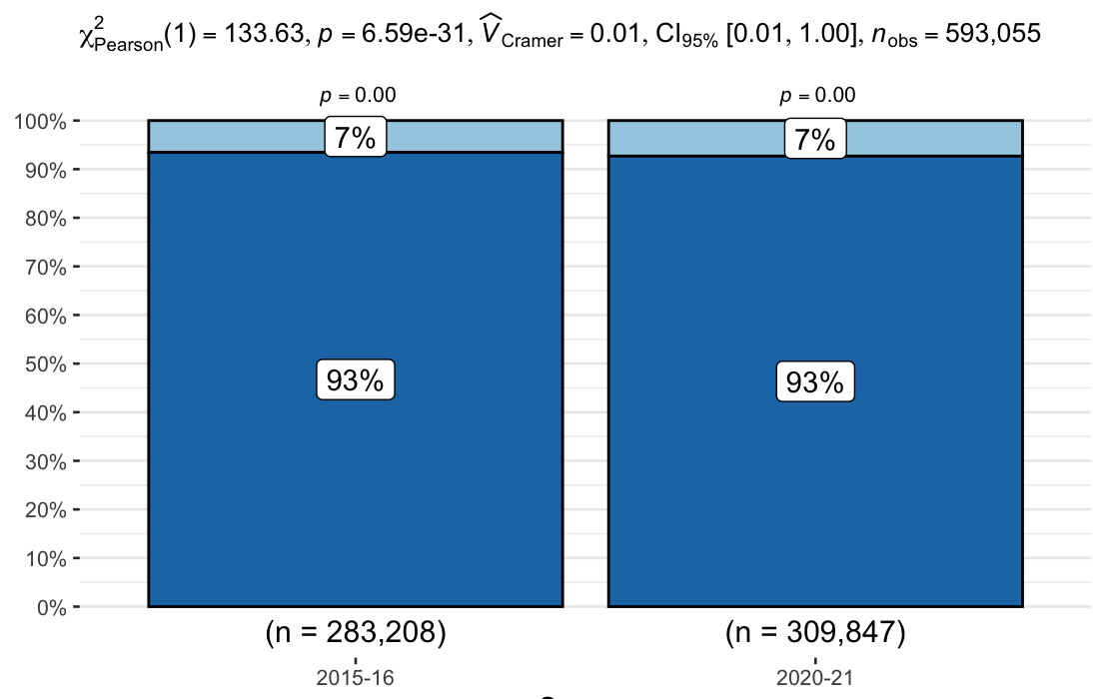 | 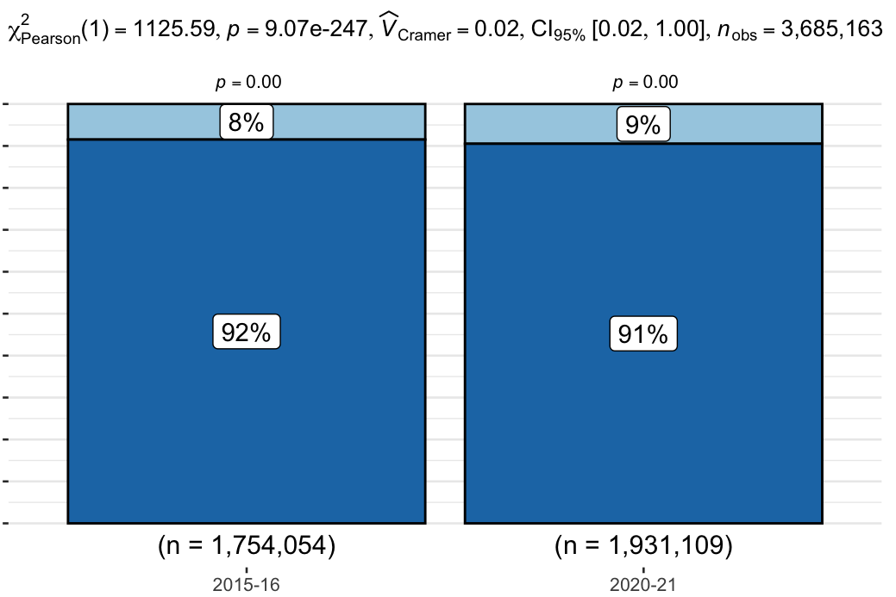 | 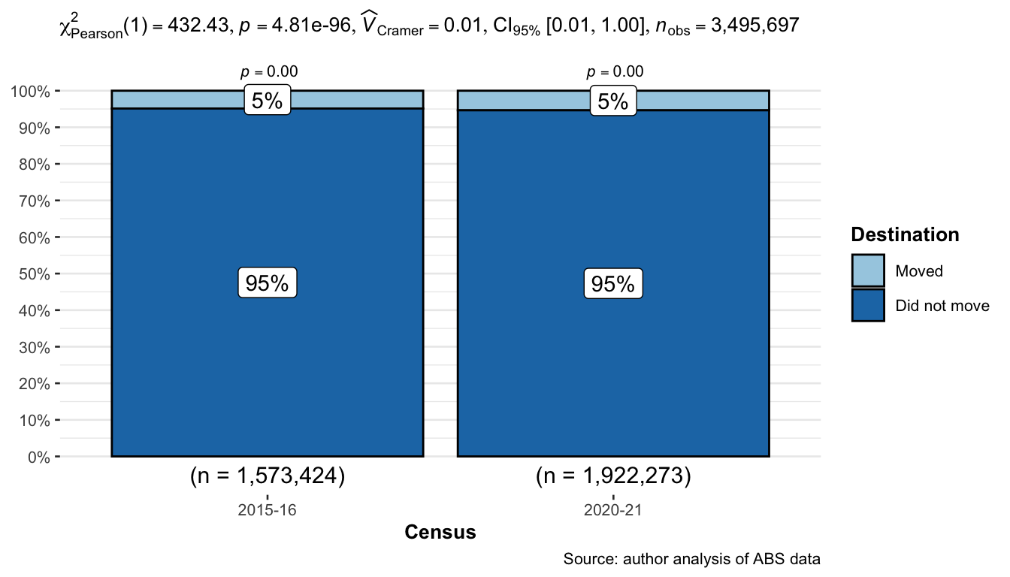
Figure 1: Residential relocation in the year before the census of people living in the inner, middle and outer regions of Melbourne one year before each census.
Source: author analysis of ABS data.

Table 5: Destinations of residential relocation (in the year before the census) of people living Melbourne one year before each census, by region
Destination | Living in inner region 1 year before census |  | Living in middle region 1 year before census |  |  | Living in outer region 1 year before census
Destination | 2015-16 | 2020-21 | 2015-16 | 2020-21 | 2015-16 |  | 2020-21
Inner | 367 (2.0%) | 544 (2.4%) | 4,379 (2.9%) | 7,347 (4.0%) | 23,344 (30.5%) |  | 37,043 (35.9%)
Middle | 1,206 (6.5%) | 1,638 (7.2%) | 33,254 (22.4%) | 37,938 (20.7%) | 15,336 (20.0%) |  | 16,831 (16.3%)
Outer | 10,166 (54.8%) | 10,226 (45.1%) | 55,710 (37.5%) | 63,157 (34.5%) | 3,649 (4.8%) |  | 5,315 (5.2%)
Peri-Urban Areas | 1,634 (8.8%) | 1,842 (8.1%) | 30,981 (20.8%) | 38,090 (20.8%) | 4,701 (6.1%) |  | 5,441 (5.3%)
Rest of Victoria | 765 (4.1%) | 922 (4.1%) | 9,732 (6.5%) | 10,500 (5.7%) | 17,879 (23.3%) |  | 17,770 (17.2%)
New South Wales | 1,942 (10.5%) | 2,558 (11.3%) | 5,213 (3.5%) | 7,258 (4.0%) | 3,560 (4.6%) |  | 5,164 (5.0%)
Queensland | 1,115 (6.0%) | 2,393 (10.6%) | 4,332 (2.9%) | 8,171 (4.5%) | 4,315 (5.6%) |  | 8,049 (7.8%)
South Australia | 259 (1.4%) | 601 (2.7%) | 1,270 (0.9%) | 2,867 (1.6%) | 809 (1.1%) |  | 1,997 (1.9%)
Tasmania | 209 (1.1%) | 984 (4.3%) | 902 (0.6%) | 2,775 (1.5%) | 603 (0.8%) |  | 2,360 (2.3%)
Western Australia | 525 (2.8%) | 385 (1.7%) | 1,382 (0.9%) | 2,065 (1.1%) | 1,349 (1.8%) |  | 1,356 (1.3%)
Northern Territory | 127 (0.7%) | 211 (0.9%) | 497 (0.3%) | 933 (0.5%) | 503 (0.7%) |  | 808 (0.8%)
Australian Capital Territory | 241 (1.3%) | 369 (1.6%) | 1,022 (0.7%) | 1,917 (1.0%) | 536 (0.7%) |  | 920 (0.9%)
Total | 18,556 (100.0%) | 22,673 (100.0%) | 148,674 (100.0%) | 183,018 (100.0%) | 76,584 (100.0%) |  | 103,054 (100.0%)

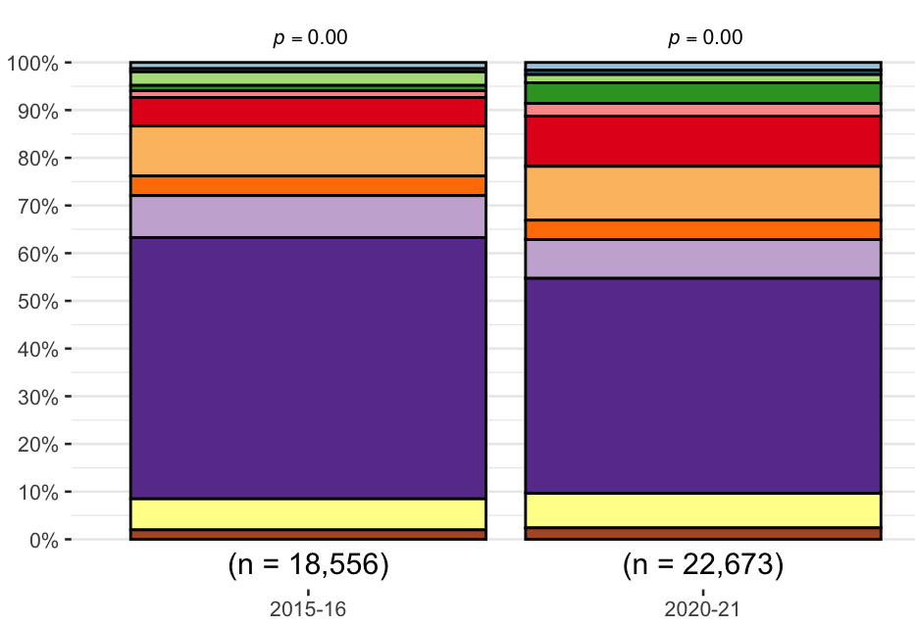 | 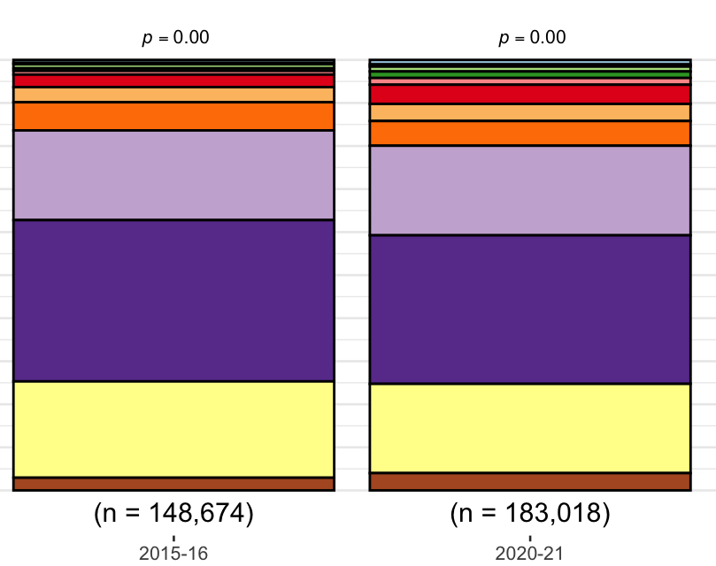 | 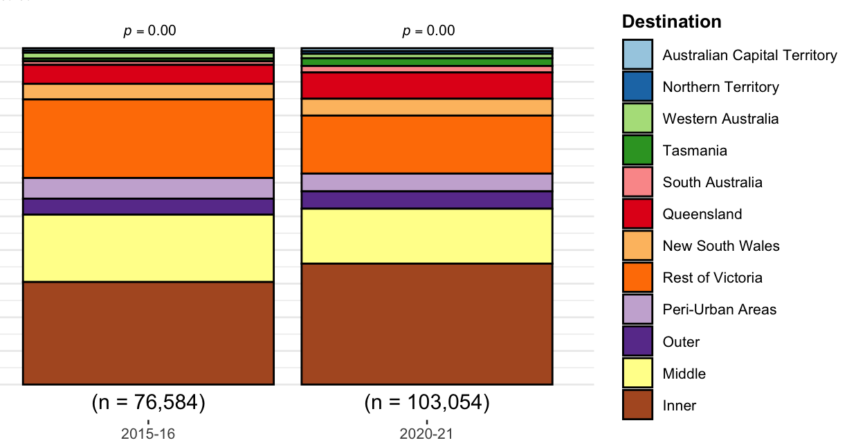
Figure 2: Destinations of residential relocation (in the year before the census) of people living Melbourne one year before each census, by region
Source: author analysis of ABS data.
Figure 2 shows how:
- Inner:
  - In 2015-16 54.8% of inner Melbourne residents who moved, moved to the outer region, compared to just 45.1% in 2020-21,
  - In 2015-16, 6% of inner Melbourne residents who moved, moved to Queensland, whereas in 2020-21 this proportion had almost double to 11%.
- Middle:
  - In 2015-16, 37.5% of middle Melbourne residents who moved, moved to the outer region, compared to just 34.5%% in 2020-21,
  - Of middle residents who moved, the proportions who moved to the inner region (2.9% to 4.0%), Queensland (2.9% to 4.5%) and Tasmania (0.6% to 1.5%) all increased by relatively small amounts between 2015-16 and 2020-21.
- Outer:
  - In 2015-16 30.5% of outer Melbourne residents who moved, moved to the inner region, but this increased to 35.9% in 2020-21,
  - There were also increases in the proportion of outer Melbourne residents who moved who moved to Queensland (5.6% to 7.8%) and Tasmania (0.8% to 2.3%),
  - In 2015-16 20.0%of outer Melbourne residents who moved, moved to the middle region of Melbourne, but this fell to only 16.3% in 2020-21,
  - There were also falls in the proportion of outer Melbourne residents who moved who moved to the rest of Victoria (23.3% to 17.2%).

Overall, Table 5 and Figure 2 suggest that there have been changes in where people who are relocating their residence actually relocate to now in the ‘with-COVID’ period, compared to pre-COVID. This analysis suggests that, compared to their likelihoods pre-COVID:
- People moving from the inner region of Melbourne are:
  - less likely to move to the outer regions of Melbourne, and
  - more likely to move to Queensland;
- People moving from the middle region of Melbourne are:
  - less likely to move to the outer regions of Melbourne, and
  - more likely to move to the inner region of Melbourne, Queensland or Tasmania;
- People moving from the outer region of Melbourne are:
  - more likely to be moving to the inner parts of Melbourne or to Queensland, and
  - less likely to be moving to the middle suburbs or the rest of Victoria.

However, as discussed previously, this analysis does not include people who moved from the inner, middle or outer regions to another country. This is because these people are not counted in the census, having already left Australia. Unfortunately, it is not possible with the available ABS datasets to account for changes in the proportional size of these people. This would seem particularly relevant in the 2020-21 (with-COVID) period, given that people who might have moved overseas might instead move elsewhere within Australia. Additionally, people who moved from inner, middle or outer Melbourne shortly after arriving in Australia (i.e. move to Australia, then move again within Australia) would seem less likely to exist in the 2020-21 period, given that Australia’s border was closed to most arrivals. As such, it appears likely that there are some confounding factors influencing the rate of residential relocations discussed above associated with how those moving to Australia subsequently shift (or do not shift) their residential location.
In summary, however, this analysis of the ABS census data suggests that:
- While changes in the rate of residential relocation in the pre-COVID versus with-COVID periods are significant, they are of relatively small magnitude, in the order of 1% or less. Hence, there does not appear to have been a large increase in the number of people moving their residence compared to before COVID-19.
- In both the pre- and with-COVID periods the number of people moving their place of usual residence each year appears to be between 1 in 11 (9.5%) and 1 in 20 (4.9%), with people living in the middle region of Melbourne moving the most and those moving in the outer region moving the least.
- People who live in the inner region may now be more likely to move to Queensland, and less likely to move to the outer region of Melbourne than they were pre-COVID.
- People who live in the middle region of Melbourne may now be more likely to move to Queensland, inner Melbourne or Tasmania, and less likely to move to the outer regions of Melbourne .
- People who live in the outer region of Melbourne may now be more likely to move to the inner region of Melbourne or to Queensland, and less likely to move to middle suburbs or the rest of Victoria

Overall, narratives that there is a ‘tree-change’ of a greater proportion of people moving from Melbourne to other places in Victoria do not appear to be supported by the available ABS census data. There has been roughly a doubling in the number of people moving from Melbourne to Queensland from around 10,000 a year pre-COVID to around 20,000 people in the year before the 2021 census. However, in the context of a overall Melbourne population of approximately 5 million, this only represents a change from around 0.2% of the population moving to Queensland per year to 0.4% per year.

There are challenges with this data because the increased interaction of the public with Medicare, due to the COVID-19 vaccination program, has resulted in a large increase in the number of people changing their address. These people may not have actually moved recently, just happened to have found out that their address details recorded with Medicare were out of date and they got vaccinated. The ABS has made adjustments to the dataset to account for this, but this means that data is not available fore all quarters.
Inner, middle and outer refer to the regions of Greater Melbourne. Peri-Urban Areas are the parts of Victoria surrounding Greater Melbourne (Geelong, Ballart, Bendigo etc.), while the rest of Victoria is more regional locations (e.g. Mildura, Warrnambool, etc.).
This is also offset by the 17,200 people moving FROM Queensland to Victoria in 2015-16 (Table 1) and 13,158 in 2020-21 (Table 2).

